Dissect Airbnb Star Rating

by Analyzing Hidden Topics from Airbnb Comments

**Introduction:**

As an active Airbnb user, I appreciate the star rating of each listing which has provided me a general understanding of how people feel about this particular listing. As an experienced Airbnb user, I know that by looking at the star rating is simply not enough to evaluate the details of the home. To gain a full understanding of what people like/dislike about the particular listing, reading the comments under each listing is a step you cannot miss. Comments are not only important to guests, they also contain important insights and suggestions for hosts regarding on future improvements. However, depends on the amount of time the listing has existed, the number of comments can be overwhelming to read through one by one. With this understanding in mind, in this project, I focus on using comments to provide insights that can be quickly understand by people without reading through all comments. This project is broken down into two main parts. First is to use unsupervised learning model to extract subtopics that people tend to talk about in comments from the most and least well-performing listings. While we are trying to make the content of the comments a bit more straightforward, this also allows us to understand if there is a difference between good listing reviews and bad listing reviews. Second, we build a model using all the words in the comments to predict the overall rating for each listing. Through understanding these topics, we then can apply these topics to each listing and give both guests and hosts insight in how well the listing is doing in relation to others in San Francisco.

**Data:**

The data used for this project is from Inside Airbnb, an “independent, non-commercial set of tools and data that allows you to explore how Airbnb is really being used in cities around the world.” In inside Airbnb, datasets are collected on monthly bases. For this project, I used data collected for all San Francisco listings on March. Data has two parts, one is the listing file which contains about 4000 listings in San Francisco with all information including hosts’ description, amenities offered at the house, and overall review score rating. The other one is the review file which contains all the reviews for each listing in San Francisco. Overall, there were about 300,000 reviews in total. With all the comments and the overall review score rating for each listing, we can build a model to understand the relationship between what people talk about in the comments and the rating for each listing.

**Exploratory Data Analysis with LDA:**

***Part 1, review rating analysis:***

To understand what are some of the key hidden topics in reviews for listings with high and low ratings, the first approach is to separate the comments based on the rating. One interesting thing to note is that majority of the Airbnb ratings has a range from 80 points to 100 points. Very rarely there is a rating below 80. In the San Francisco dataset, out of three hundred thousand reviews, only 600 reviews are the ones associated with reviews score of below 80 points. With such observation, separating comments based on 0 to 100 rating scale would not be feasible because we simply do not have enough data to extract any subtopics. The approach I adapted is to use comments from listing with lower than 80 point of rating score. This way, we then can make sure there are enough information for the model to search upon and extract the subtopics. In comparison to the poor performing ratings, on the other hand, I used comments from listings with 100 points of rating score to understand what are the different topics customers tend to talk about when they express their satisfaction.

***Latent Subtopics with Latent Dirichlet Allocation:***

Latent Dirichlet Allocation (LDA) is a generative probabilistic model for collections of discrete data such as text corpora. LDA is a three-level hierarchical Bayesian model, in which each item of a collection is modeled as a finite mixture over an underlying set of topics. Each topic is, in turn, modeled as an infinite mixture over an underlying set of topic probabilities. In the context of text modeling, the topic probabilities provide an explicit representation of a document. [1]

In the context of this project, all comment collected from listings after count vectorization is the collection of the text corpora. Each comment is treated as a bag of words of certain size and then is assigned to a topic via the Dirichlet Distribution. With stop words removal, bigram specification, 15 subtopics is extracted from the comments.

As an example, the breakdown of the top 4 topics and the words distribution for comments from listings with 100 points several topics is shown in the table below.

|  |  |  |  |
| --- | --- | --- | --- |
| Topic 1 (11.2%) | Topic 2 (9.9%) | Topic 3 (9.5%) | Topic 4(9.3%) |
| definitely stay | Great location | Walking distance | Quick respond |
| Highly recommend | Like home | Public transportation | Clean comfortable |
| Look forward | Great view | Shop restaurants | Great place |
| Host responsive | Feel like | Short walk | Great host |

The same process is done to comments from listings with less than 80 points, and the top 4 topics distribution is shown in the table below.

|  |  |  |  |
| --- | --- | --- | --- |
| Topics 1 (10.6%) | Topics 2 (9.9%) | Topics 3 (8.9%) | Topics 4 (6.2%) |
| Great host | Arrival automated | Good location | Homeless people |
| Location great | Automated posting | Location close | Surrounded homeless |
| Good experience | Host canceled | Location really | Drug addicts |
| Good price | Canceled reservation | Room got | Homeless drug |

***Part II, sentiment analysis:***

From looking at the subtopics from LDA model, words with positive sentiment seems to be a big part of the comments. To dig a little deeper into the sentiments behind all the comments, I used a sentiment analysis package from both NLTK and Google Language API to analyze the sentiment for each comment. Due to the inefficiently long amount of time Google Language API takes, although the result from Google Language API’s sentiment analysis seems more accurate, we focus on discussing the result of the sentiment analysis using NLTK package. The NLTK sentiment analysis gives you four parameters in measure the sentiment of the comment. They are, positive, neutral, negative and compound. Positive, neutral, and negative all range from 0 to 1 where 0 means the least relevant and 1 means the most relevant. While compound range from -1 to 1 where -1 represents absolute negative sentiment and 1 represents absolute positive sentiment.

After measuring all the sentiment of comments, the next step is to understand what the distribution of the sentiment looks like. After plotting a histogram of the sentiment based on compound score, we see the following distribution:

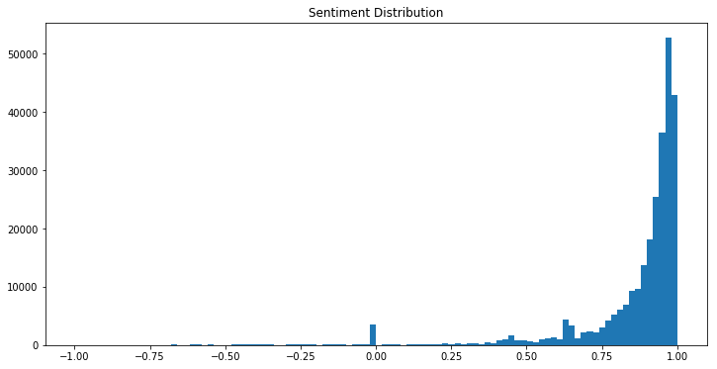

As you can see, most sentiment are positive and concentrated around 0.8 to 1 which mean that most comments on the listing are expressing guest’s satisfaction instead of dissatisfaction. If you take the rating distribution into account, this distribution of the sentiment is following the same shape of the rating scores where more of the ratings are also concentrated above 80 points.

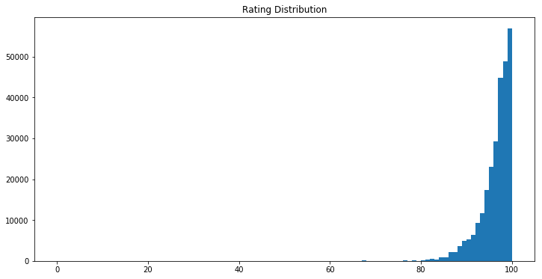

Knowing that most comment’s sentiments are positive, it is still important for us to understand what kind of words people tend to use to express their satisfaction and joy towards to stay. Therefore, another LDA was performed based on sentiment compound score where positive sentiments are all comments with compound score greater than 0.5, negative sentiment are comments with compound score less than -0.3. The topics extracted from analyzing comments based on sentiments gave us a good understanding of what are the keywords people tend to use to express their good/bad sentiment. This finding will be extremely important for the next step which is to perform hidden topic analysis for each listing.

**Hidden Topic Analysis:**

Based on the unsupervised learning model LDA, we now have a good understanding of what are some of the hidden topics that guests tend to mention when they leave a comment. From both the rating LDA analysis and sentiment analysis, there are eight key topics that will greatly influence the performance of a particular host. These eight topics are the following:

1. Good sentiment
2. Convenience
3. Host positive attitude
4. Amenities mentioned
5. Cancelation
6. Environment issue
7. Bad sentiment

Each of the topics above contains keywords/phrases that are extracted from the LDA analysis which will be used to measure individual host performance based on the relevancy of each topics mentioned in their comments.

For example, take host with id number 27025. This host has a review rating of 100 which is among one of the highest rating. If we take a look at this host’s hidden topic relevancy, we can see the distribution as following:

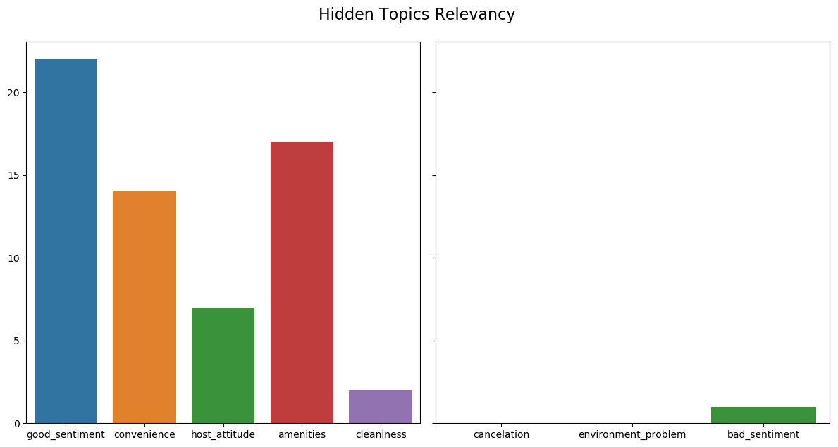

Let’s compare the result of a host who has a lower rating score of 76, this host’s hidden topic relevancy looks drastically different from the host with good rating score:

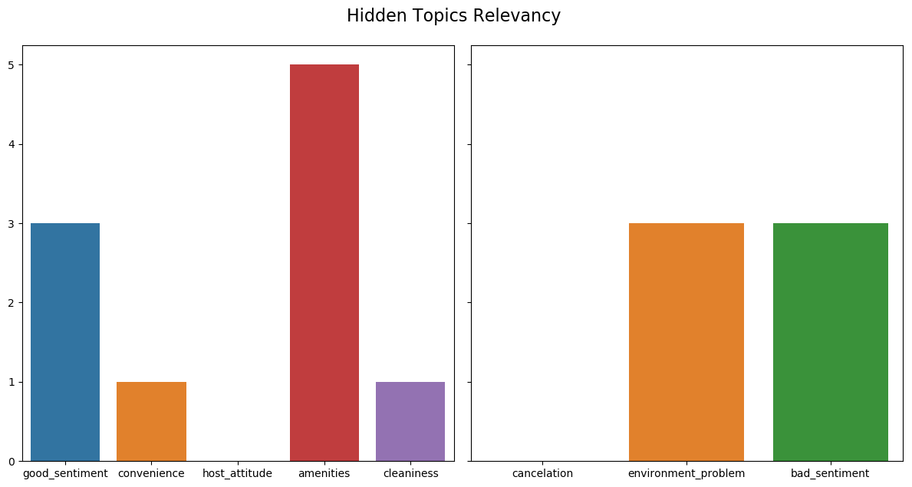

For a listing with good rating, the hidden topics relate to good sentiments are way more relevant comparing to a poor performing listing. Since this metric is completely based on comments, both host and guests and use this metric to evaluate the house. For this particular example, the host can go to the comments with bad sentiments in it and understand why this particular guest had a bad experience and act on it. Also, cleanliness is only mentioned once for all 30 comments, perhaps this will lead to host understanding that they need to improve on the cleanliness of their property.

**The Long Short-Term Memory Prediction Model:**

Based on previous finding of words in hidden topics, we can see that the comments in listings with higher ratings tend to focus on certain topics comparing to the comments in listings with lower ratings. In this case, we can understand the rating of a particular listing represent the aggregate sentiment of how people feel towards their experience. With this finding, I am interested in building a model where we use purely words from the comments to predict the rating for each listing. The hypothesis is that, if we see a listing with high rating, and the comments people tend to leave for good rating listings also tend to have a certain topic within them, we might be able to build a model that understands the relationship between the comments and the rating.

**The intuition behind this model:**

**The model: LSTM**

Long Short-Term networks introduce a memory into the model. Having a memory in a network is useful because text is sequenced data and the meaning of a word depends on the context of the previous text. A shortcoming of the Recurrent Neural network is that it is only capable of dealing with short-term dependencies. Long Short-Term networks address this problem by introducing a long-term memory into the network. A Long Short-Term model is built to find the rating score for listing given reviews from guests. [2]

Similar to sentiment classification analysis, in this model, we have review score that represents how people feel towards the listings. The score is range from 0 to 100 and is provided by each guest who also had left a comment about this place. Although each listing is dependent from each other, they still share a lot of common topics as we had discovered above.

**Result:**

The current LSTM model has no prediction power. The model successfully picked up the average of all ratings and will only give the average result back despite the fact that you feed it new sets of data. Although the result of the model is not worth interpreting, we can try to understand why the model is performing poorly.

First, most of the reviews are positive and between the range of 80 to 100 and this score is simply someone hitting the screen and there is no context behind it. From the guest’s point of views, a high star rating simply doesn’t mean much in terms of evaluating the quality of the property. Second, the model is only good at picking up reviews with high rating because the entire dataset is filled with listings with high ratings. There are not enough low rating comments for the model to learn and understand what are the topics people tend to talk about when giving a bad rating to a listing. Third, the rating score for this dataset is an average score of all the ratings guests had given in the past. We do not have a clear understanding of how each guest has provided their rating when they leave the comments. Unlike a rating which you can average over, comments are words and can’t be average over. Therefore, using all the comments to predict one averaged number is simply hard to do.

**The Alternative LSTM Model: sentiment rating instead of star rating**

I believe the biggest reason why the model has failed to predict the rating of the listing is because there is simply not enough connection between comments and the rating score itself. The failure of the model also raised another question, how useful is it for both the guest and the host to look at the rating and draw any meaningful conclusion knowing that the score is a “polite” score people give and the comments can say otherwise.

To fill be gap between what the rating represents and what people are people actually saying about their experience, I purposed using sentiment analysis score to represent the actual rating for each listing.

There are many sophisticated packages and tools build by professional data scientists to detect the sentiment of each comment. After applying sentiment analysis onto each comment, we can then average all sentiment scores and transform the score into a sentiment star rating. For sentiments that are on the negative side, the system can put a flag on that comment for host and guests to review later.

For the purpose of learning sentiment analysis, I too had built a LSTM model to preform sentiment analysis